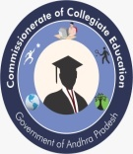**GDC GUMMALAKSHMIPURAMPARVATHIPURAM MANYAM DIST**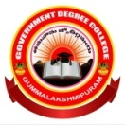

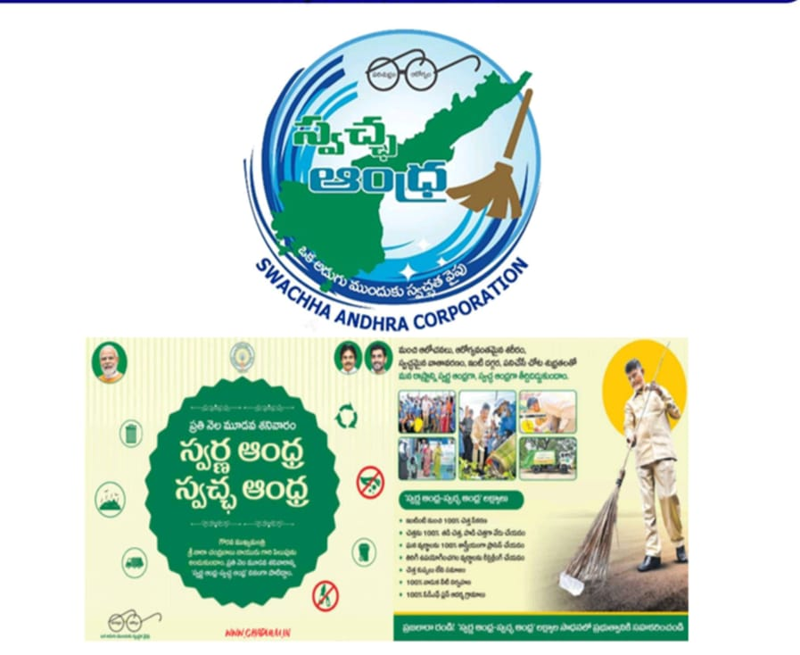

**SWARNANDHRA- SWACHH ANDHRA**

**15th Februa“Souce- Resourse”**

**Report**

 **GDC GUMMALAKSHMIPURAM**

**NATIONAL SERVICE SCHEME**

**TABLE OF CONTENTS**

1. **Message from the Principal**
2. **College swachaata committee**
3. **Swachh Andhra Pledge**
4. **Orientation Program On Purity Concepts And Hand Wash**
5. **February Theme Source Resource**
6. **Campus Cleaning**

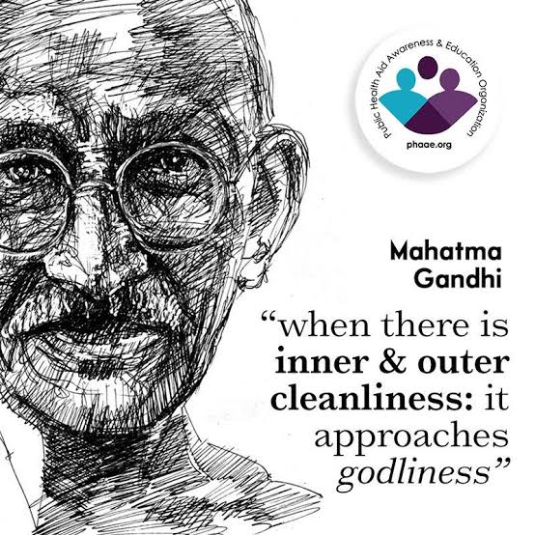

**Message from the Principal**

**Dr. T. Sreevaram, Principal of Government Degree College, Gummalakshmipuram, emphasized the importance of the Swarna Andhra – Swachh Andhra programme in fostering responsible citizens. This initiative aims to create a cleaner and more sustainable Andhra Pradesh by promoting effective waste management. February Õs theme, "Source-Resource," highlights the need to manage waste at its origin. A key focus is implementing a 3-bin waste segregation system to categorize waste into dry waste (plastics, glass, metal, and paper), wet waste (organic matter for composting), and hazardous waste. This practice reduces landfill burden, promotes recycling, and enhances resource recovery. The programme also raises awareness of personal hygiene, public health, and environmental responsibility. Students are encouraged to actively participate, understanding their role in sanitation and sustainability. Dr. T. Sreevaram everyone to take this initiative seriously, making Swarna Andhra – Swachh Andhra not just a campaign but a way of life, ensuring a cleaner and greener future.**

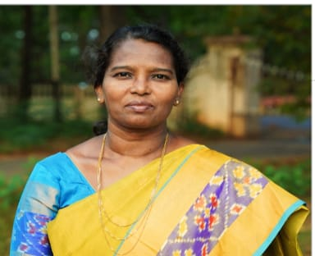

**GOVT. DEGREE COLLEGE, GUMMALAKSHMIPURAM, PARVATHIPURAM MANYAM DIST**

**COLLEGE SWACHAATA COMMITTEE**

|  |  |  |
| --- | --- | --- |
| **S.No** | **Member** | **Name & designation** |
| **1** | **Chair Person** | **Dr. T. Sreevaram Principal** |
| **2** | **Nodal Officer** | **Sri D. Ramaiah NSS PO** |
| **3** | **Faculty Member** | **Kum A. Srivani NSS PO** |
| **4** | **Faculty Member** | **Smt K.Tulasi Lecturer in Mathematics** |
| **5** | **Student Volunteer** | **P. Padmini** |
| **6** | **Student Volunteer** | **A.Mahesh** |
| **7** | **Non-Teaching Staff** | **M. Manamadharao** |
| **8** | **Non-Teaching Staff** | **P. Lokesh** |

**3. SWACHH ANDHRA PLEDGE**

**A Swachh Andhra Pledge was conducted with great enthusiasm at GDC, Gummalakshmipuram reinforcing the commitment to cleanliness, hygiene, and environmental sustainability. The event aimed to inspire students, faculty, and staff to actively contribute to the Swachh Andhra mission by maintaining cleanliness in their surroundings and spreading awareness among the community. The ceremony was attended by Principal T. Sreevaram along with teaching, nonteaching staff, and students, who collectively pledged to uphold the values of cleanliness and responsible waste management.**

**The Swachh Andhra Pledge was then administered, where all participants vowed to:**

* **Maintain cleanliness in their homes, classrooms, and public spaces.**
* **Encourage waste segregation into wet, dry, and hazardous categories.**
* **Say no to plastic and promote the use of biodegradable materials.**
* **Educate others about the importance of cleanliness and hygiene.**
* **Participate in community cleaning drives and environmental awareness programs.**

**After taking the pledge, students and staff actively engaged in a cleanliness drive within the campus and nearby areas. Equipped with gloves and garbage bags, they picked up litter, segregated waste, and educated passersby on the importance of cleanliness. Posters and banners with slogans like "Clean Andhra, Green Andhra!" and "Swachh Bharat, Swachh Andhra!" were displayed to reinforce the message.**

**The event concluded with a motivational message from faculty members, encouraging students to be ambassadors of cleanliness and spread the message of Swachh Andhra beyond the institution. The initiative left a lasting impact, fostering a sense of responsibility and inspiring continuous efforts toward a cleaner and healthier environment.**

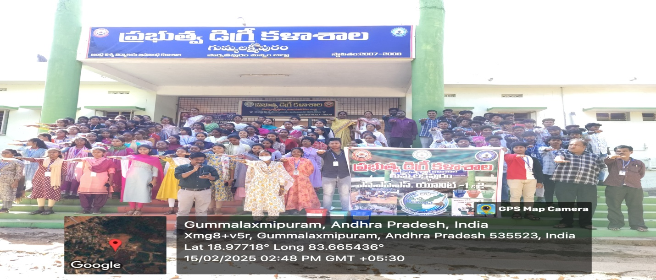

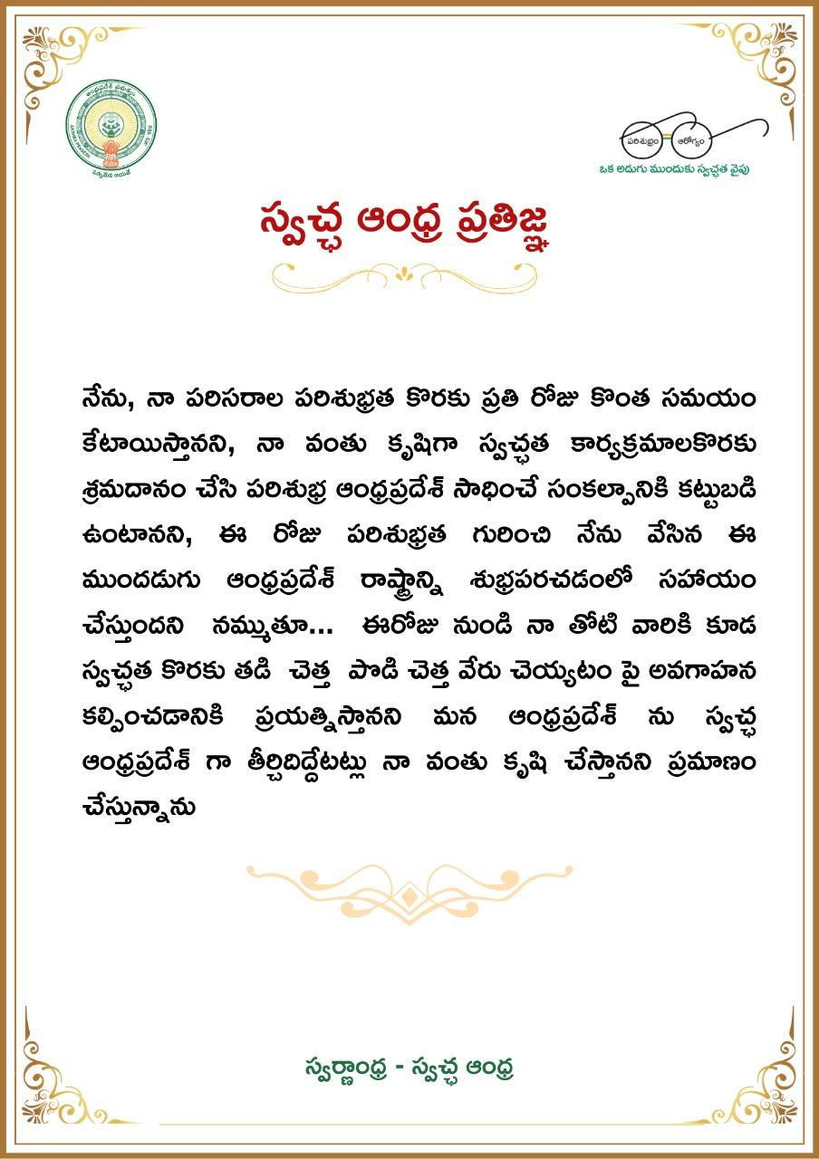

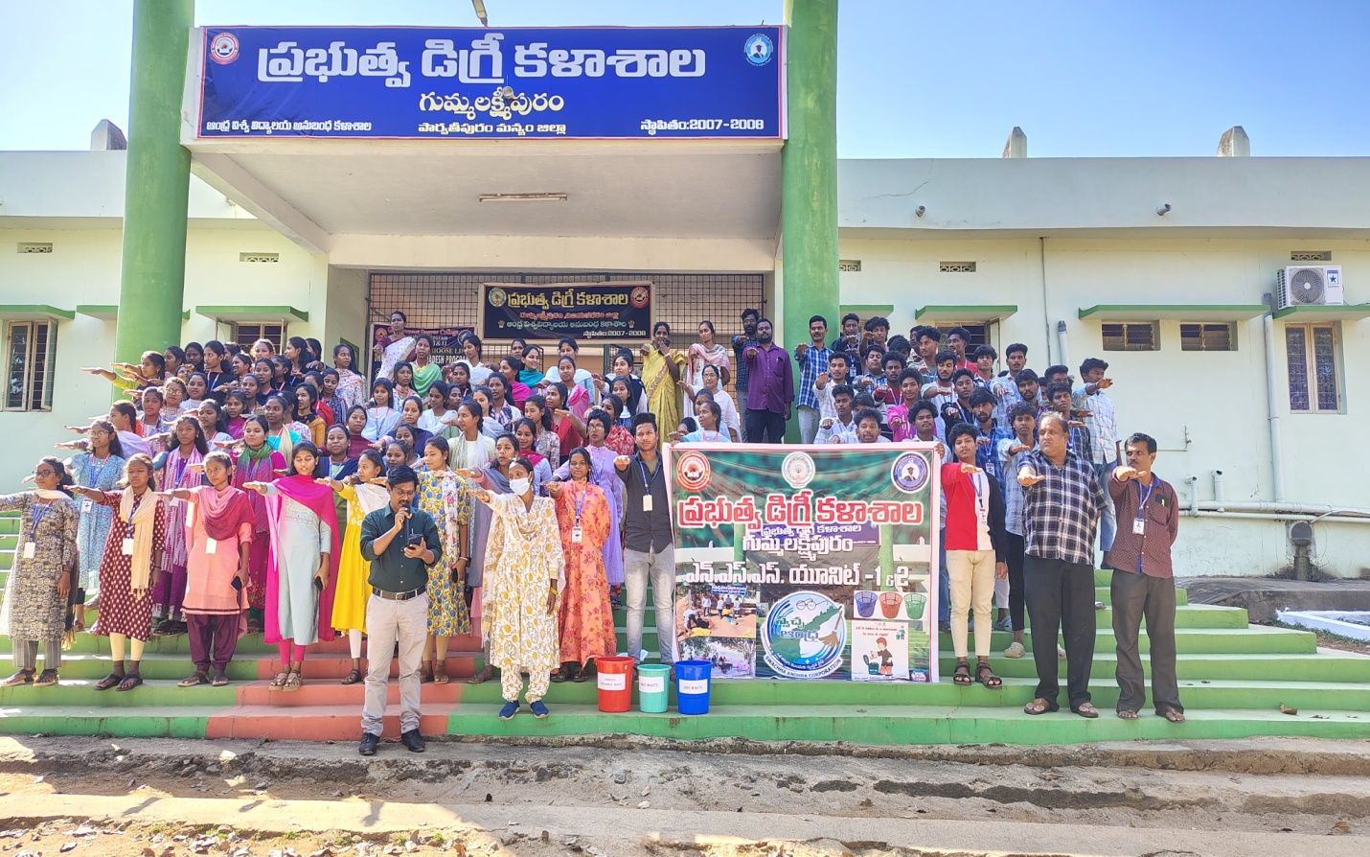

**4. ORIENTATION PROGRAM ON PURITY CONCEPTS AND HAND WASH**

**An Orientation Program on Purity Concepts and Hand Wash was successfully conducted to educate participants about the importance of hygiene, cleanliness, and maintaining purity in daily life. The event aimed to create awareness on proper hand washing techniques and the significance of clean food, water, and surroundings to prevent infections and promote good health. The program witnessed active participation from students, faculty members, and community representatives.**

**The session was graced by Principal Dr T. Sreevaram, who addressed the gathering and emphasized the critical role of hygiene in maintaining a healthy lifestyle. In his speech, he highlighted how regular washing and purity in food hand and water can significantly reduce the spread of diseases. He encouraged everyone to adopt proper hand washing habits and follow cleanliness practices in their daily routines.**

**The program included a live demonstration on effective hand washing techniques, where volunteers and health experts illustrated the seven-step hand washing method using soap and water. The importance of washing hands before meals, after using the restroom, and after touching unclean surfaces was stressed. The correct use of hand sanitizers and their role in maintaining hygiene were also explained.**

**To make the session more interactive, a practical hand washing activity was conducted, where participants practiced the correct technique under supervision. Informative pamphlets and posters were distributed, reinforcing key messages about hygiene and purity. The event concluded with a pledge by all attendees to maintain cleanliness, practice proper hygiene, and promote awareness about purity in their communities. The initiative was well-received and left a lasting impact on participants, encouraging them to adopt healthier habits for a safer and cleaner environment. And Pledge made by Principal Dr T. Sreevaram to develop more purity for pure thoughts, pure mind and pure lifestyle**

**1. I pledge with me that together we all can build a clean and green Andhra Pradesh, and with clear intentions to keep clean homes, green surroundings and clean workplaces.**

**2. Pledge to separate organic waste, garden waste, and other biodegradable materials for composting**

**3. I pledge to encourage home composting or community composting to make organic fertilizers and use them effectively on the top of the house or in kitchen gardens.**

**4. I pledge to segregate waste such as plastics, paper, glass and metals from dry waste and recycle or up cycle them.**

**5. I pledge to segregate hazardous wastes i.e. materials like batteries, drugs and chemicals and provide them for safe handling and avoid any harm to environment and health from them.**

**I think everyone's role is crucial in achieving “Swarna Andhra Swachh Andhra” by starting to segregate our waste into wet, dry and hazardous categories.**

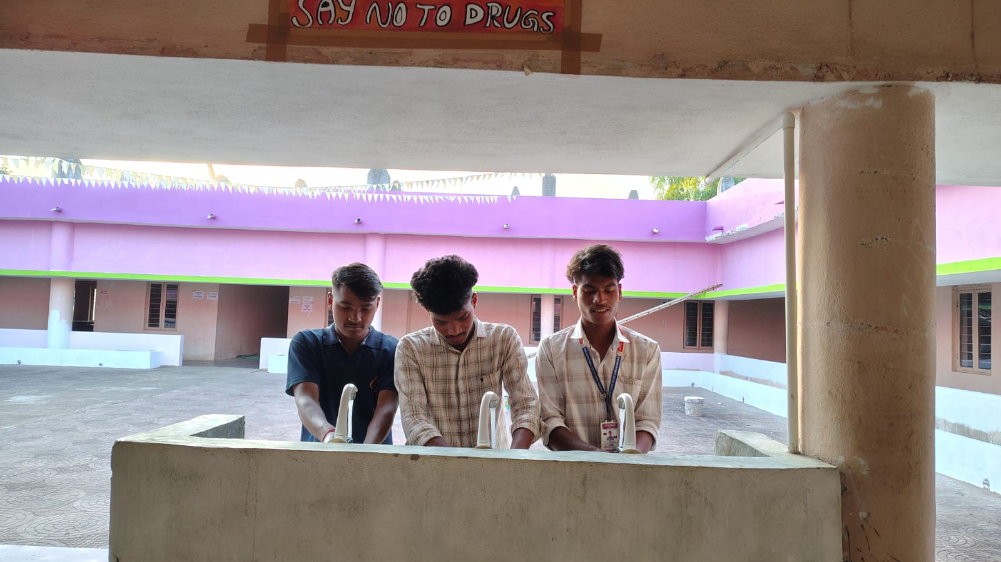

**February Theme “Source – Resource”**

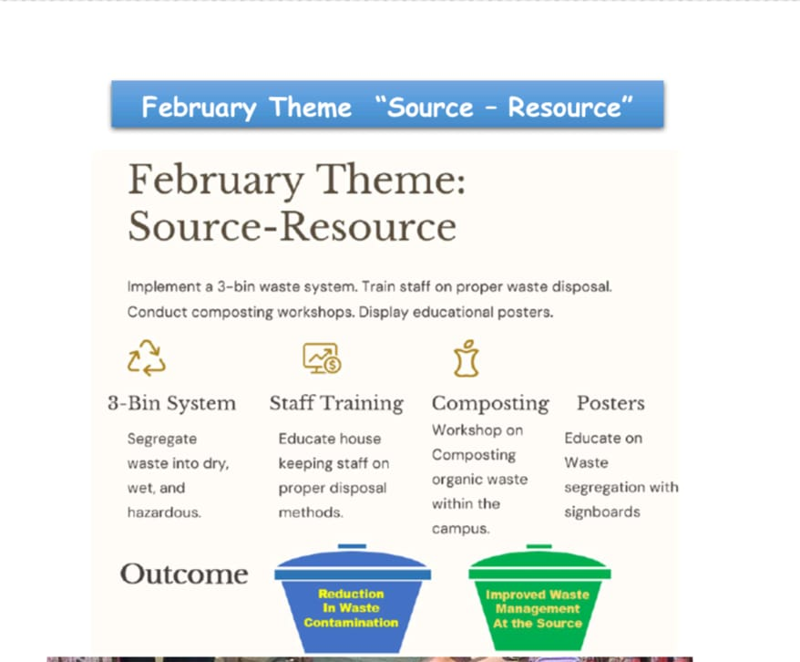

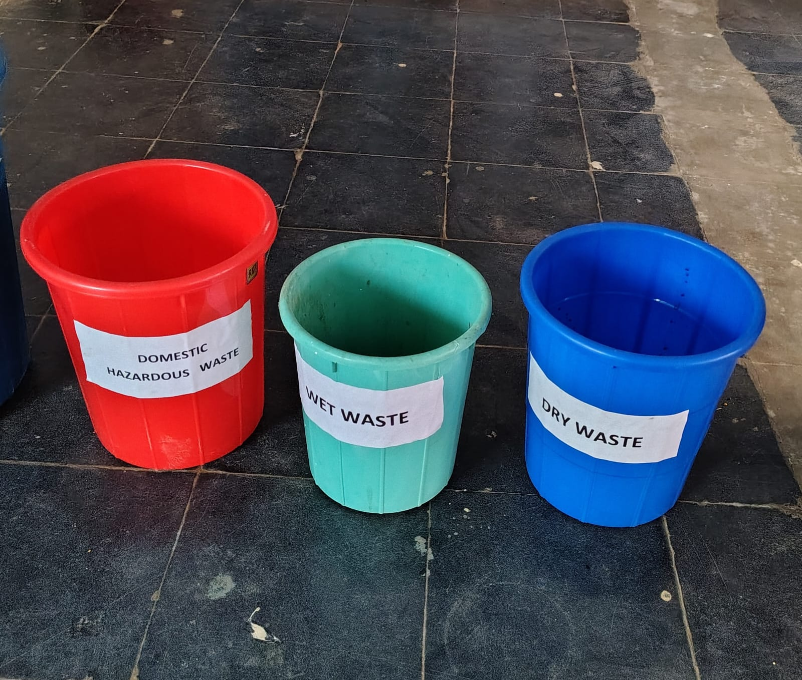

**The importance of waste segregation into three distinct streams Wet Waste, Dry Waste, and Hazardous Waste. This initiative aimed to encourage responsible waste disposal practices, promoting a cleaner and healthier environment. Volunteers, including students, faculty members. Wet Waste (Biodegradable Waste) – This includes kitchen waste like vegetable peels, food scraps, fruit skins, and garden waste. Residents were advised to compost wet waste or dispose of it in green bins for organic recycling.**

* **Dry Waste (Recyclable Waste) – Materials such as paper, plastic, glass, and metal**¬ **fall under this category. Households were encouraged to keep dry waste separate for recycling to reduce landfill burden.**
* **Hazardous Waste – Items like batteries, expired medicines, chemicals, and**¬ **electronic waste were classified as hazardous. Residents were made aware of the dangers of improper disposal and were instructed to dispose of hazardous waste through authorized collection centers.**
* **Kum A. Srivani, Lecturer in History & D. Ramaiah Lecture in Telugu demonstrated how to use color-coded bins to separate waste effectively and shared pamphlets detailing the benefits of proper waste segregation. They also educated residents on the environmental impact of mixed waste disposal, which leads to pollution and health hazards.**

**To ensure long-term impact, the campaign emphasized community participation, urging households to adopt sustainable waste management practices.**



**6. CLEANING OF THE INSTITUTE AND PREMISES**

**1. The cleaning activities were carried out in different sections of the campus premises. Teams were assigned specific areas, including classrooms, laboratories, staff rooms, playgrounds, and botanical garden spaces. Volunteers were provided with gloves; face Masks, brooms, dustpans, garbage bags, and cleaning materials to effectively remove dust, litter, and unwanted debris. Special attention was given to segregating waste into wet, dry, and hazardous categories for proper disposal.**

**2. During the drive, students removed waste materials, cleaned furniture, swept floors, and ensured that garbage bins were placed in designated spots for easy waste disposal. Outdoor areas such as gardens, and Terrace Litter were cleared of plastic waste, dry leaves, and other pollutants by Arika Mahesh and Gedala Tharun. A group of volunteers also worked in botanical garden, Removing of weed plants and watering plants, excess of branches of trees were trimmed and reinforcing the importance of greenery in maintaining a pollution-free campus.**

**3. To make the cleaning drive more impactful, awareness posters and banners with slogans like "Clean Campus, Green Campus!", "A Clean Institute is a Healthy Institute!", and "Swachh Andhra, Swachh Bharat!" were displayed across the premises.**

**4. The event concluded with a reflection session where students and faculty shared their experiences and discussed ways to maintain cleanliness as a regular practice rather than a one-time activity. Dr. T. Sreevaram Principal and staff appreciated the dedication of all participants and encouraged them to make cleanliness a lifelong habit. The successful execution of the cleaning drive reinforced the collective commitment to a clean, hygienic, and eco-friendly institute, setting an example for future generations to follow.**

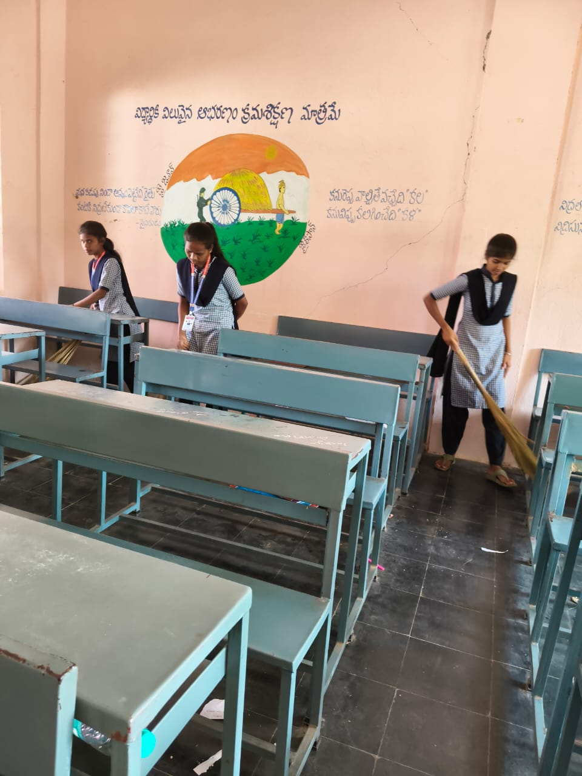

**Class Room Cleaning By Students**

