Report on National Science Day Celebration

**Date:** 28th February 2024  
**Venue:** Seminar Hall, GDC Gummalakshmipuram  
**Organized by:** Departments of Science

The **Science Departments** of **Government Degree College, Gummalakshmipuram** enthusiastically organized **National Science Day** on **28th February 2024** to honor the discovery of the **Raman Effect** by **Sir C.V. Raman**. The theme for the year was **"Indigenous Technology for Viksit Bharat"**.

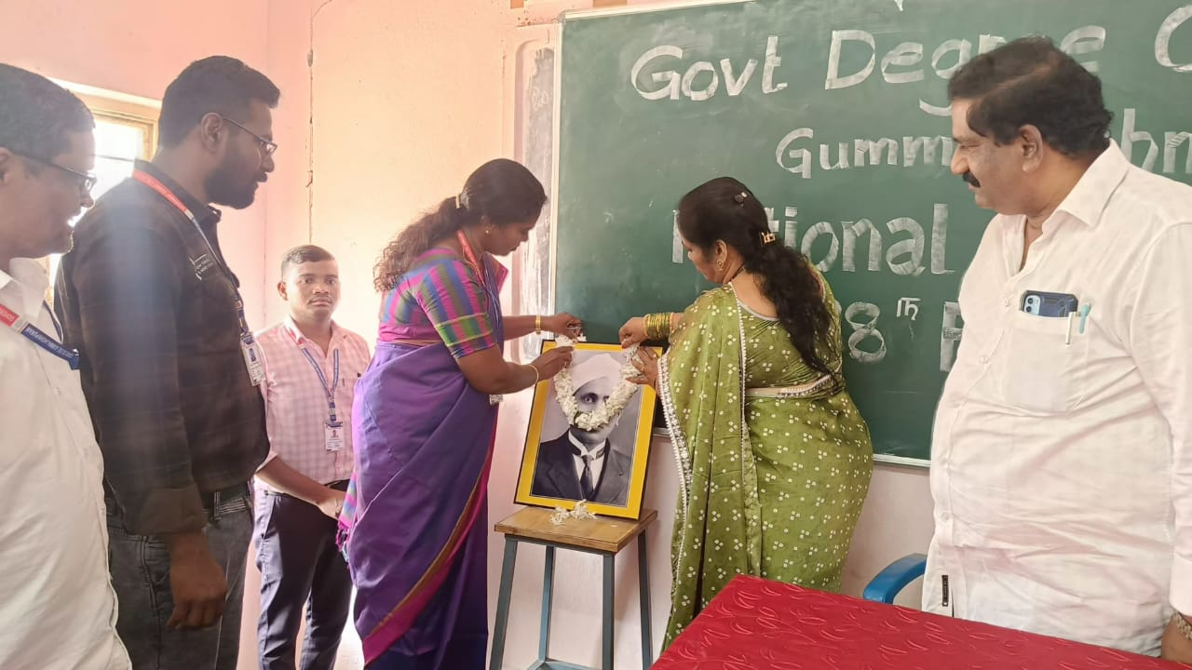

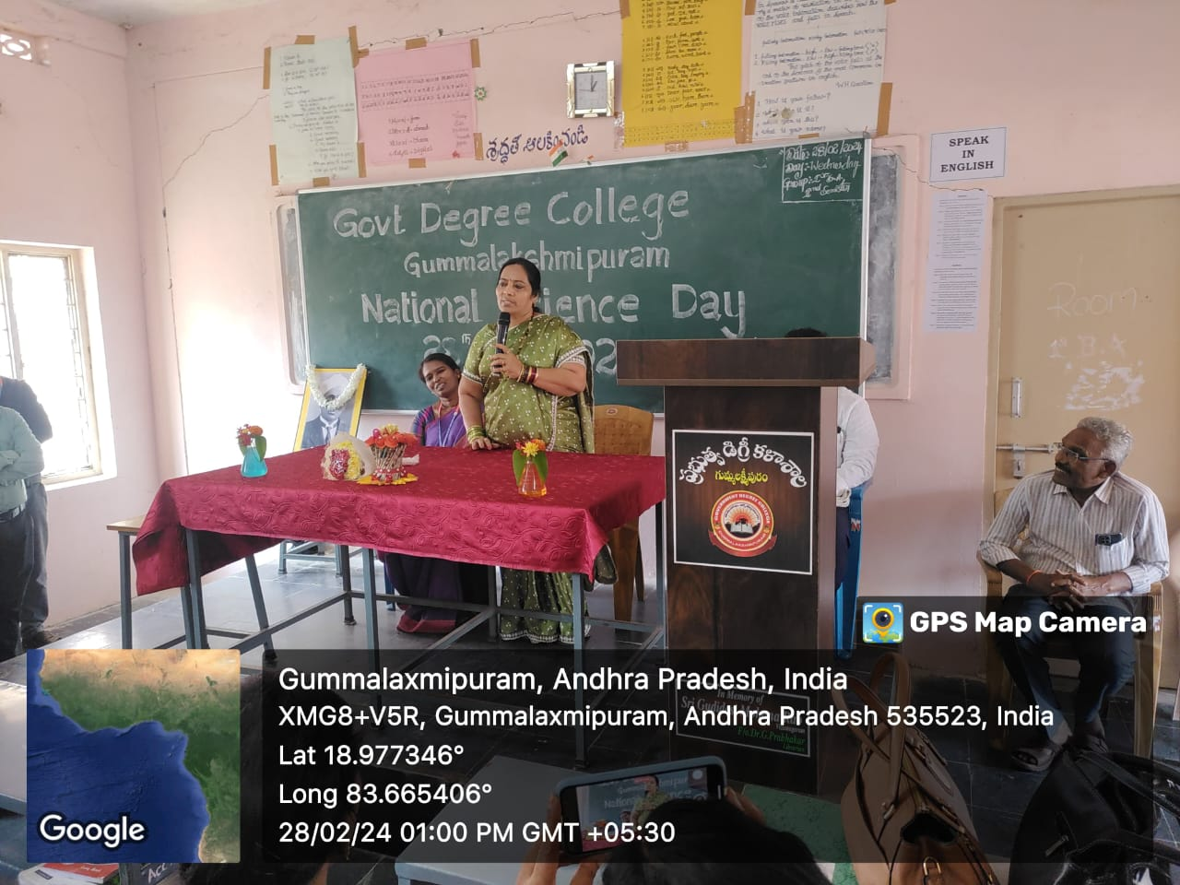

The **Chief Guest** for the event was **Dr. S. Sobharani**, **Regional Joint Director of Collegiate Education (RJDCE), Rajamahendravaram**. She inspired the students with her motivational address, emphasizing the importance of indigenous scientific knowledge and innovation in shaping the future of India. She also encouraged the students to embrace challenges and strive for excellence in scientific endeavors.

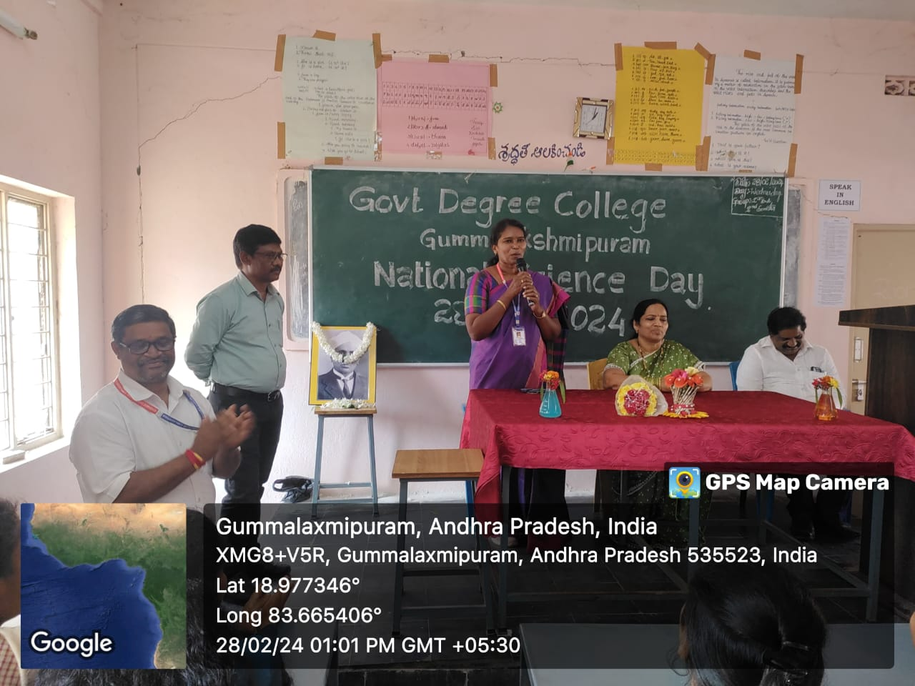

The **President of the Programme**, **Dr. T. Sreevaram**, **Principal of the College**, addressed the gathering and highlighted the significance of celebrating National Science Day. She emphasized the role of science in everyday life and its transformative power in building a self-reliant India.

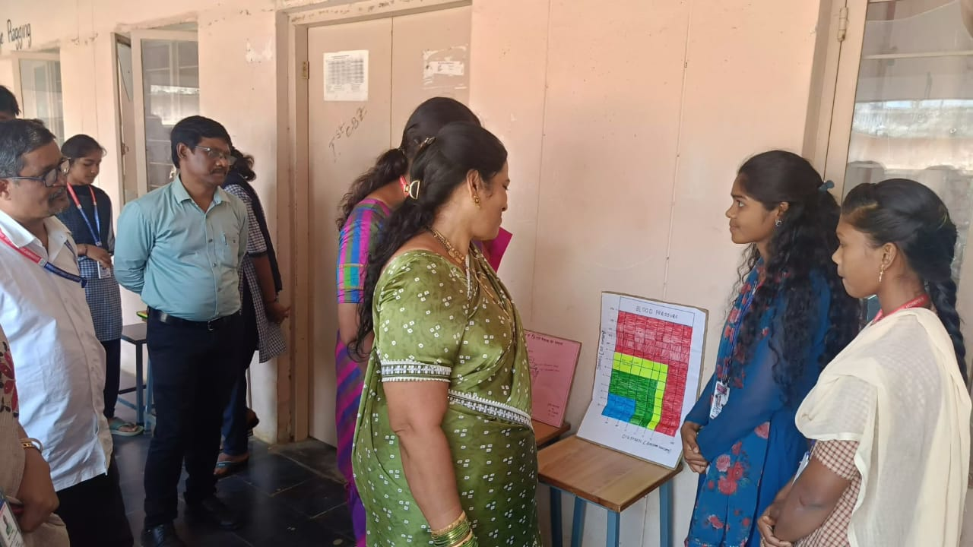

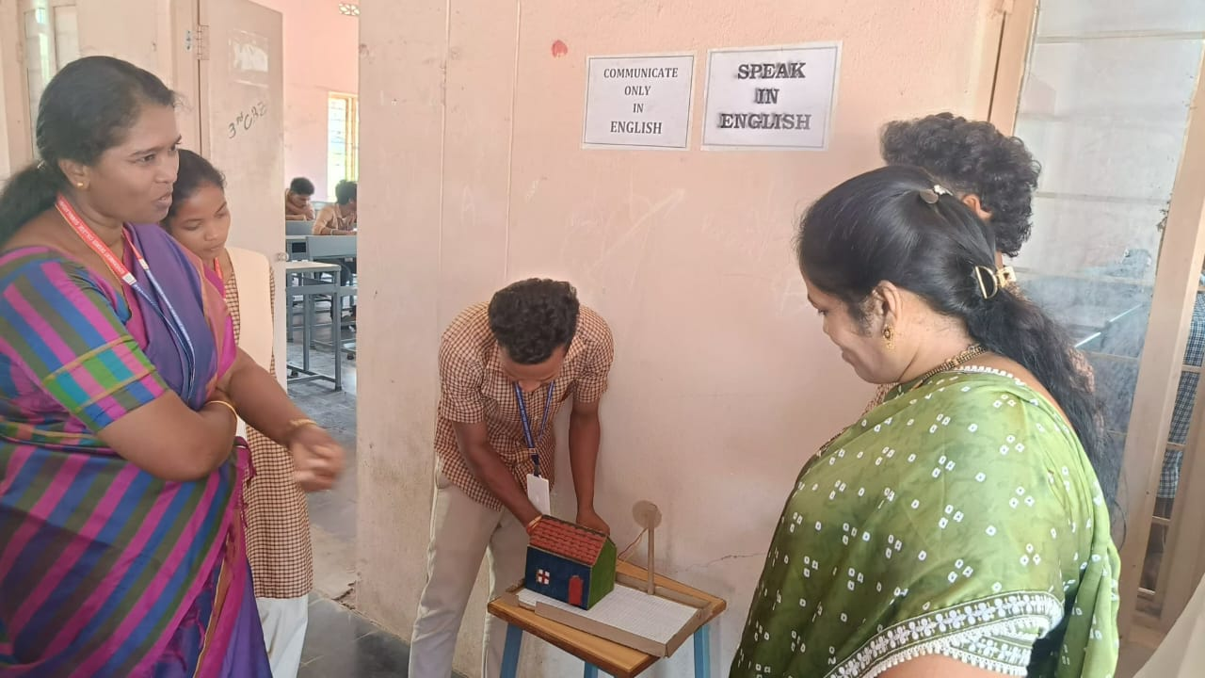

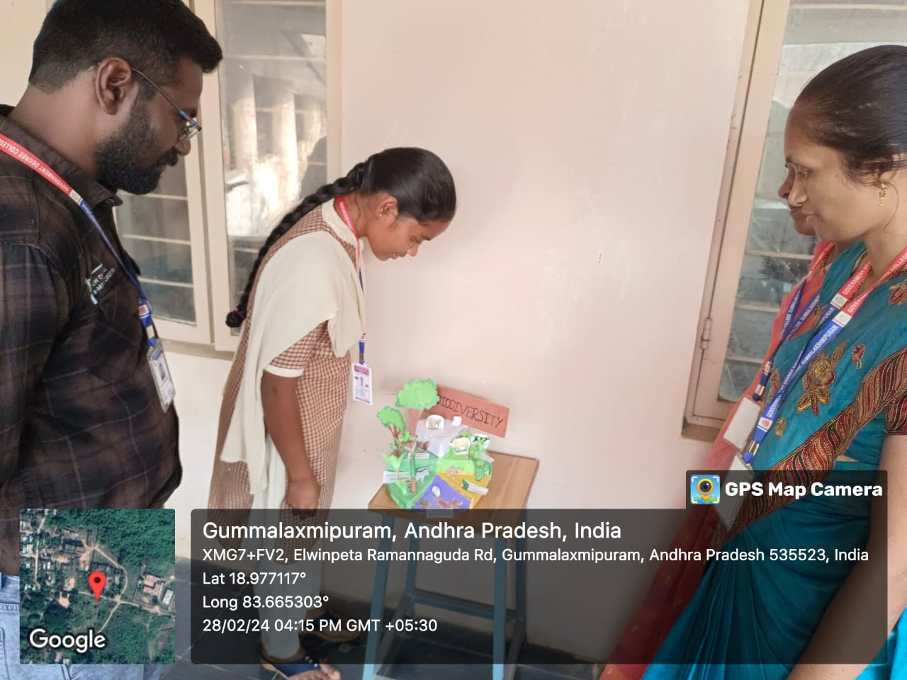

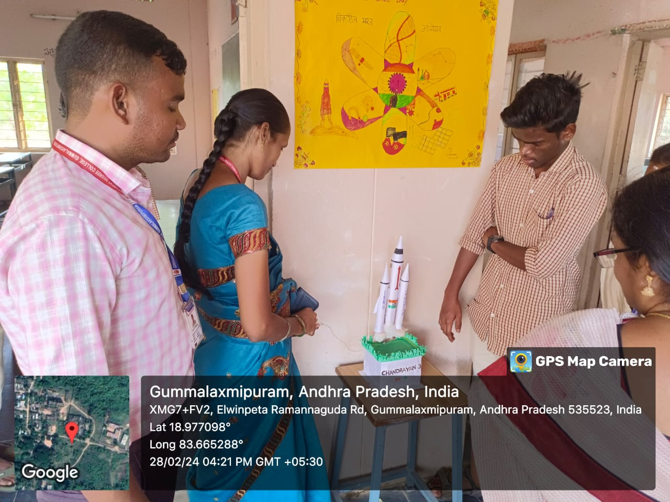

**Events and Activities:**

Several science-related competitions and exhibitions were conducted, including:

* **Essay Writing Competition**
* **Science Quiz**
* **Poster Presentations**
* **Working Science Models**
* **Chart and Photo Displays**

More than **60 to 80 students** actively participated in these events. Their exhibits and performances showcased creativity, scientific understanding, and a spirit of innovation. Students from various departments demonstrated working models and displayed thematic posters reflecting scientific ideas and sustainable technologies.

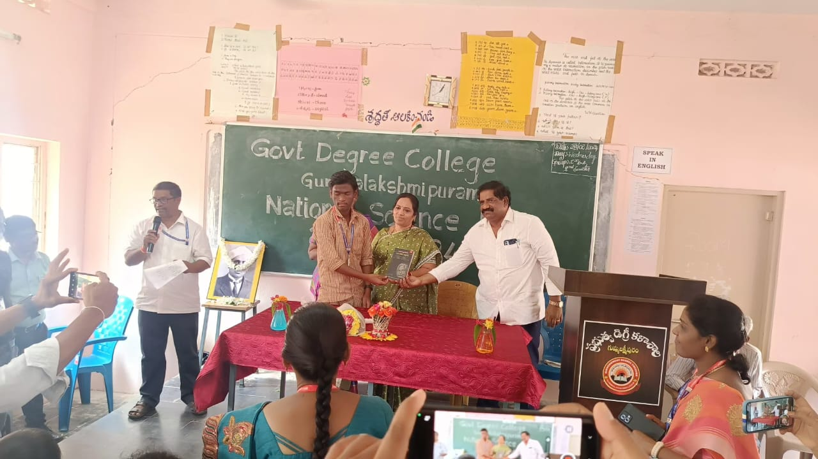

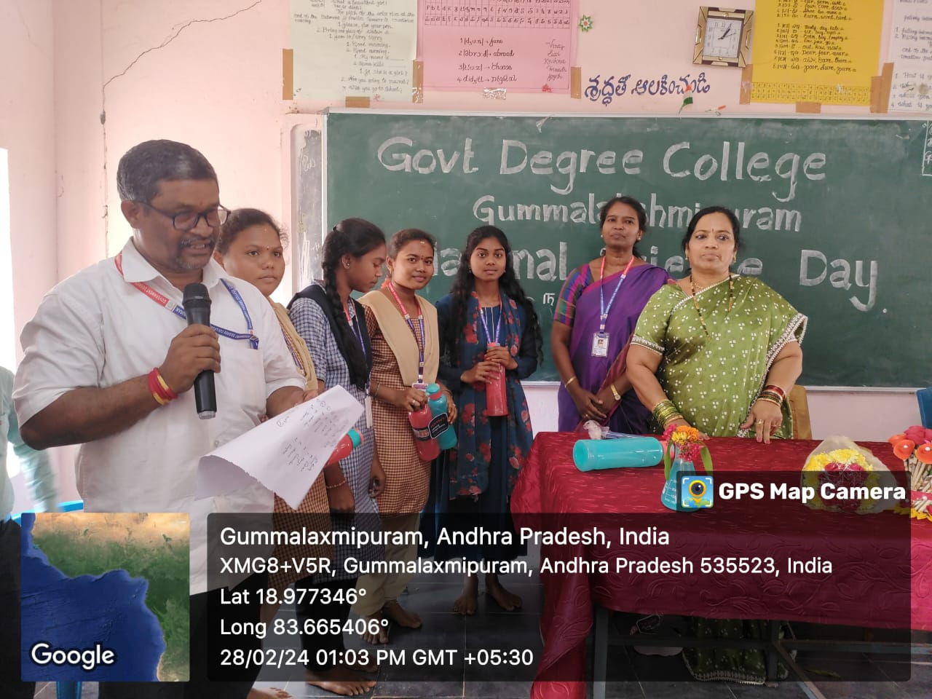

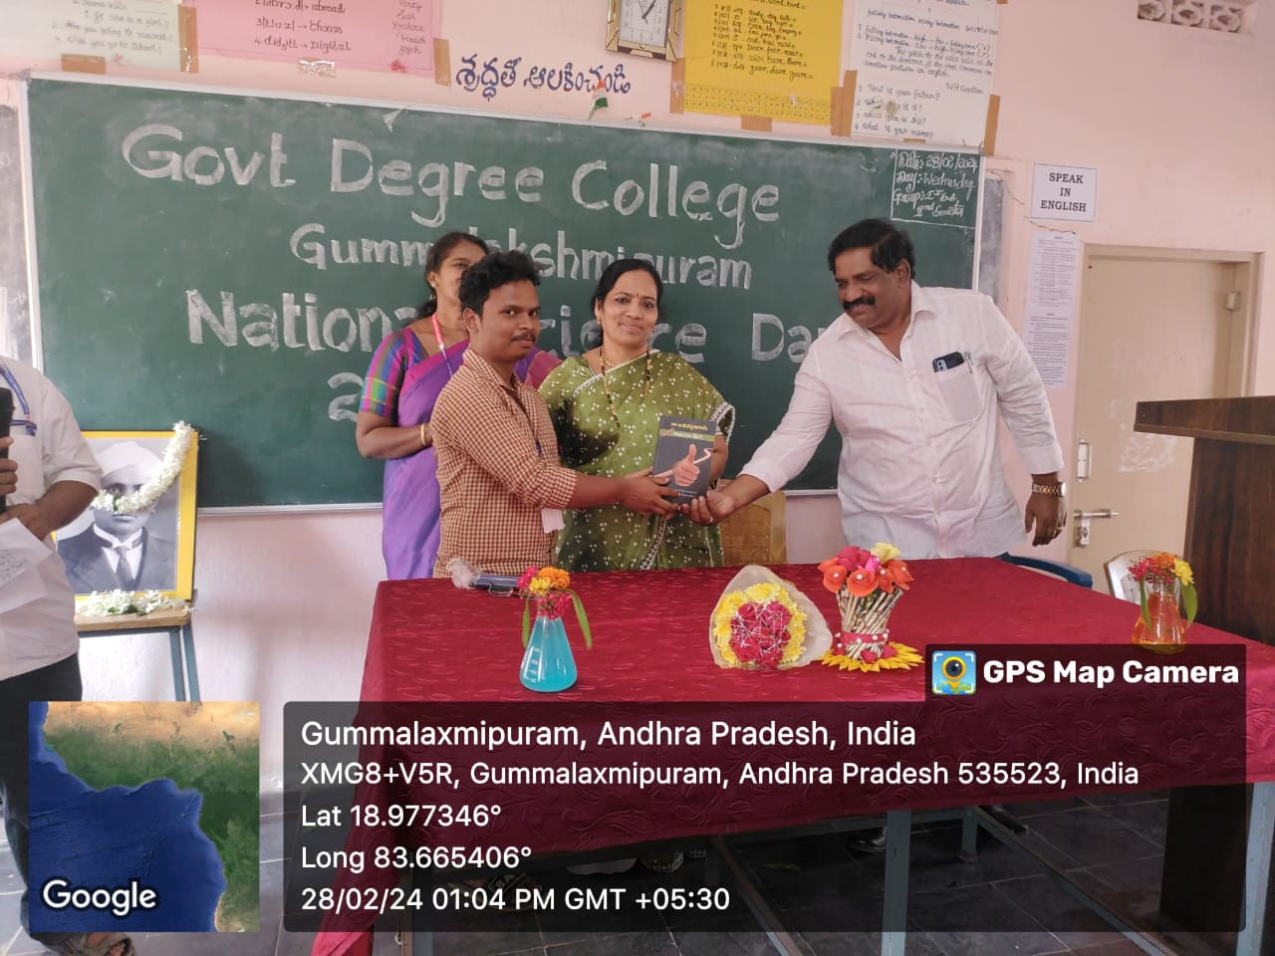

**Prize Distribution:**

The winners of the competitions were awarded prizes by:

* **Dr. S. Sobharani**, Chief Guest and RJDCE, Rajamahendravaram
* **Dr. T. Sreevaram**, Principal and President of the Programme

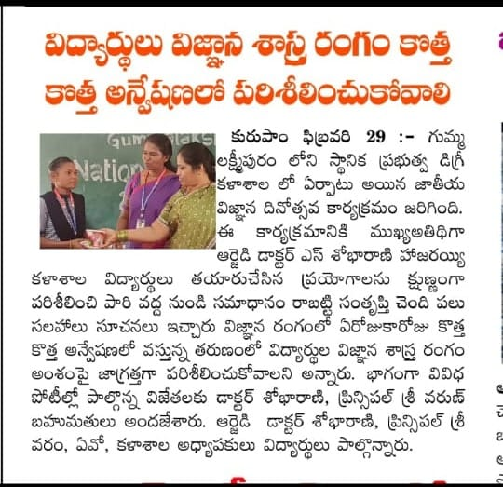

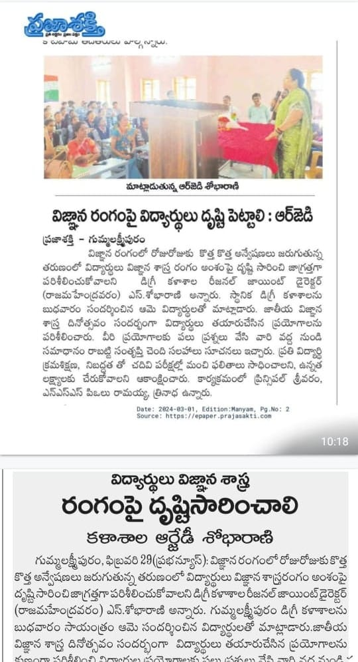

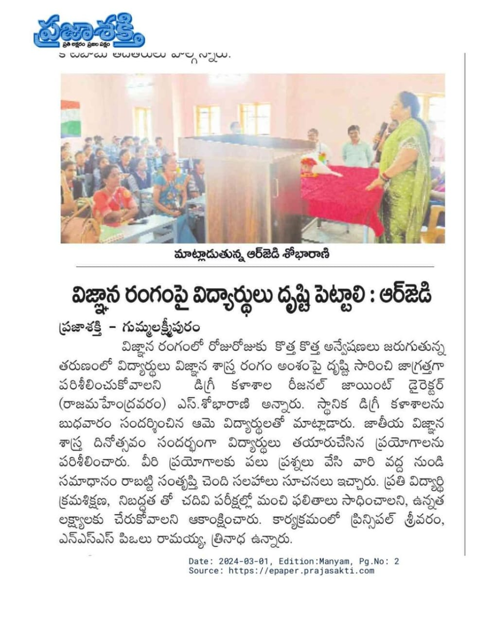

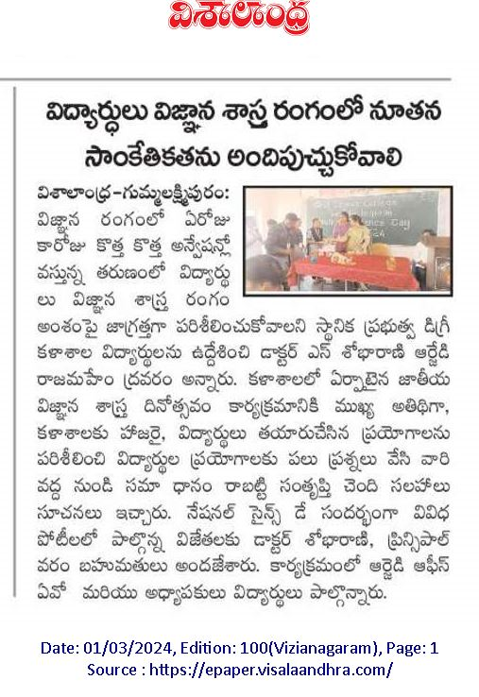

The programme concluded successfully, instilling scientific spirit and enthusiasm among students and encouraging them to contribute meaningfully to India’s scientific and technological development.